Connecting Community College Students to Non-Tuition Supports
During the COVID-19 Pandemic

Christine Baker-Smith, Japbir Gill, Sara Goldrick-Rab, Eric Bettinger, Gregory Walton, Shannon Brady,
and Elizabeth Looker

2022

EXECUTIVE SUMMARY
The COVID-19 pandemic is an ongoing critical challenge for higher education as students are experiencing setbacks on- and off-campus that impact their college trajectories and community colleges likewise struggle to implement practices to support and retain these students. The potential for learning loss and significant life trajectory interruptions looms large. Students today struggle to meet their basic needs while also suffering from anxiety, depression, and other mental health issues. Surveys show that many students in distress are not connected to resources that may help them and a fall 2020 nationwide survey found that the leading reason is lack of information. Stigma around needing help also holds students back from accessing resources they know about.

This study examines an inexpensive way for community colleges to overcome those barriers and connect students to key resources including emergency aid and advising, which may lower their non-tuition expenses and improve their well-being. In collaboration with The Hope Center for College Community, and Justice, Dallas College (a large urban community college in Texas) experimented with two types of text messages: one offering students information about resources and another offering both information and supportive language designed to reduce stigma. Beginning in fall 2020, the first fall semester of the pandemic, those weekly nudges went to more than 9,000 students, urging those with need to apply for emergency aid and seek help from college navigators (a type of advisor). We examine how these nudges influence senses of empowerment and connectedness to their institution. We also compare the use of those supports among students receiving each type of nudge to a comparable group of students (selected at random) who were not nudged but could nonetheless seek support.

Over the 2020-2021 academic year, nudging substantially increased the rate at which students applied for emergency aid (from about 32% for students who were not nudged to 37% for students that were nudged) and increased their outreach to college navigators (from about 3% for students who were not nudged to 4% for students who were nudged). Compared to information-only messages, nudges reducing stigma were more successful at making students feel empowered. This is especially helpful when encouraging them to apply for public benefits. However, they do not lead to differences in students’ support-seeking behaviors. In that regard, both types of nudging are equally impactful.

There is some modest but inconsistent evidence of effect heterogeneity by students’ gender, age, and race/ethnicity and substantial variation in behaviors according to students’ Expected Family Contributions. Information about college navigators is particularly impactful for students from the most financially vulnerable backgrounds, whereas information about emergency aid is most impactful for students who often receive less grant aid and rely more on loans and work to pay for college.

Overall, it appears that low-cost text messaging to students about supports during the pandemic increases their use of those programs. This is an important form of support, especially while emergency aid is relatively plentiful and eligibility for public benefits is more expansive. Whether improving students’ access to these supports yields academic returns remains to be seen. Implications for practice and further research are discussed.

INTRODUCTION
The COVID-19 pandemic is having a substantial impact on American higher education, particularly on community colleges where enrollment has sharply declined. Instruction has changed modality, students have lost jobs, and staff struggle to meet students’ pandemic-related needs. These changes exacerbated an already difficult situation for community college students who faced shortfalls in funds for food and housing long before the pandemic began. Supports for students’ non-tuition expenses are essential to help students stay enrolled, healthy, and well. To be effective, those supports need to consider students’ stress and mental health as well as the tight resources at most community colleges.

Community colleges are trying to connect students with several types of support, including small-dollar emergency aid funds and advisors who can help them secure basic needs supports such as unemployment insurance or benefits from the Supplemental Nutrition Assistance Program (SNAP). Beginning in the latter half of 2020 the federal government-funded emergency aid at all community colleges for the first time, and philanthropy stepped up as well. Moreover, in early 2021 eligibility for public benefits expanded for college students, making it easier for students to qualify.

These seemingly critical supports are remarkably under-utilized, even among students with evident financial need. For example, a fall 2020 survey at community colleges nationwide found that 61% of students experienced basic needs insecurity yet almost half of those students did not receive any public assistance and nearly 80% did not receive emergency aid.

A lack of information about these programs was the leading reason why students did not connect with support. That same survey found that two-thirds of students had not heard of an emergency aid program at their institution, almost three-fourths mistakenly thought they were ineligible for public benefits, and half did not know public assistance programs existed or how to apply. In addition, stress, anxiety, and depression were widespread. A smaller but substantial number of students (about one in four) said they were embarrassed to apply for help.

Many such programs have previously relied on word-of-mouth and other informal networks as their primary mechanism of recruitment to provide services. While these are a common source of information, they are hampered by the information available to the network, which is often incomplete or inequitably dispersed. Moreover, several studies suggest that those most stigmatized for seeking help are the least likely to use informal networks, hampering the efficacy of this approach for those who are already structurally marginalized. Additionally, it is possible that informal networks do not contain accurate information, which can impede their efficacy. This study examines what happened when one large urban community college district used centralized text messaging to alert students to available non-tuition supports and urge them to apply. The specific messaging in nudging often varies and we consider two alternatives to help practitioners refine their approach. In addition, because targeting messages to specific groups of students is an option for improving efficacy, we examine whether the effects of nudging varied for different groups of students that can be identified with administrative data.

THEORETICAL FRAMEWORK AND PRIOR RESEARCH
As previously noted, there are two evident challenges when it comes to connecting community college students to non-tuition supports: a lack of information and feelings of shame and stigma. This paper examines an approach to overcoming each of these challenges by communicating campus resources to students using nudges drawing on models and evidence from sociology, psychology, and economics.

IMPROVING ACCESS TO INFORMATION

Available supports for students’ non-tuition expenses, including food and housing, will not be used if students are unaware of them. Economic theory suggests that individuals cannot act rationally, in this case by seeking support, without equal access to information and accurate information. But many community colleges struggle to disseminate information about non-tuition supports at scale and rely on word of mouth to inform students. This is at least partly due to inadequate resources for marketing and communications. Oftentimes information is distributed in ways that exacerbate inequality.

While disseminating information is a common problem for many safety net programs, there are two challenges with community colleges’ traditional approaches to outreach (i.e., word-of-mouth, physical mailings, or email). First, students commute to campus and many attend part-time. In turn, they have less knowledge of on-campus resources. Second, some students do not rely on their institutional email regularly, potentially making emails less effective at disseminating information. In a recent study, emails at a small community college were quite effective at connecting students to basic needs supports, so this may depend on institutional size or other contextual factors.

REDUCING SHAME AND STIGMA

In addition to how information is delivered to students, the framing of that information may also impact how it is received. Students need to feel comfortable accessing resources, but sometimes shame and stigma deter them. If students feel ashamed, stigmatized, or have other negative feelings about using available supports, they are unlikely to do so.

Like the challenges of sharing information, shame and stigma are common problems in other fields providing benefits as well. Consider anti-poverty cash transfers, often an essential resource for people struggling to make ends meet. In the higher education context, these cash transfers are often deployed as “emergency aid.” Depending on how they are messaged, this type of financial support may risk conveying those recipients are deficient or helpless.

A study of residents living in informal settlements in Nairobi, Kenya tested the effects of representing aid in a way that empowers those in need of the support. Participants received a small cash payment equivalent to two days’ wages. For some residents, this payment was attributed to the “Poverty Alleviation Organization” whose goal involved “reducing poverty and helping the poor meet their basic needs,” a common representation of aid. For others, the payment was attributed to the “Individual Empowerment Organization” or the “Community Empowerment Organization” whose goals, respectively, were to enable people “to pursue personal goals and become more financially independent” and “to support those they care about and help communities grow together.” The representations titled “Empowerment” avoid labeling recipients as poor and highlight opportunities for growth. Both led residents to choose to view more videos teaching business skills important to their work (e.g., how to calculate a profit) rather than leisure videos (e.g., soccer highlights). The “Empowerment” representations also led participants to feel greater self-efficacy to accomplish life goals and to anticipate greater improvement in their social standing over the next two years. Similarly, in a study of students in higher education, the authors found that connecting stories to the use of resources encouraged students to use those resources.

NUDGING

One of the ways that communities of practice attempt to address low utilization rates of supports is by providing information on and/or encouragement to take up services, also called ‘nudging.’ Many scholars have examined ways to conduct nudging through cost-effective approaches such as emails and text messaging. In higher education, many studies focus on nudging for financial aid activities or advising and find mixed to null results on academic outcomes. For example, a study of a national dataset of approximately 10,000 students found nudging towards Free Application for Federal Student Aid (FAFSA) re-filing improved re-filing rates but had no discernable impact on actual aid or academic outcomes. Another study, which took place at a four-year public university, identified positive effects of phone-based outreach from a call center on rates of on-time FAFSA re-filing for continuing students, slightly increasing the amount of aid (primarily state aid) that students received. However, the increase in aid did not result in increased retention to the next year of college.

But a more recent study conducted by The Hope Center found that nudging community college students to use a centrally located basic needs center on campus more than doubled students’ use of that key support. The intervention was tested at a small community college in the Texas Panhandle beginning in 2018, before the pandemic. Those nudges were delivered once a month via email and signed by a well-known campus administrator who leads the basic needs center. Higher resource utilization rates translated into at least some academic gains: students in developmental education (a key stumbling block on the road to completion) were about 20% more likely to pass their courses and move on to college-credit-bearing coursework.

In addition, a study examining a nudging campaign at Western Michigan University employed text messages to encourage students to use food pantries and found that increased retention rates by 12 percentage points and eased food insecurity. In other fields such as social work, the impact of providing increased access to information and encouragement to take up public services has also shown encouraging results.

Table 1 outlines five principles or tools for how to communicate “bad” events in ways that forestall pejorative interpretations. Anti-poverty cash aid interventions foregrounded Principles 1 (Prevent negative labels) and 5 (Recognize opportunities). The present study incorporated these lessons in designing messaging.

TABLE 1 | ATTUNED MESSAGING: PRINCIPLES FOR REPRESENTING BAD EVENTS NEGATIVELY

PRINCIPLE | DESCRIPTION
1. Prevent negative labels | When people experience negative events, they risk labeling themselves in fixed, negative ways or perceiving that others could label them as such. Effective reframings forestall negative labels, and encourage a fundamentally positive view of the self, of factors that led to the bad news (e.g., normal, malleable), and of the person’s prospects.
2. Communicate “You’re not the only one” | People can think that they are the only one facing a particular challenge. Effective reframings recognize others who have faced the same challenge and describe how they addressed that challenge productively.
3. Recognize specific nonpejorative causes | People can fear that bad things reflect, or could be seen as reflecting, a deficiency (e.g., laziness, stupidity, immorality). Effective reframings acknowledge specific, nonpejorative causes of challenges or setbacks and legitimize these as normal obstacles that arise for many people.
4. Forecast improvement | People can fear that negative events forecast a fixed, negative future. Effective reframings emphasize the possibility of improvement, focus on process, and often represent this process collectively (we’re on the same team/I’m not judging you).
5. Recognize opportunities | In some cases, it is possible to represent aspects of the “bad” event as positive, meaningful, or useful, and thus not just as something to be overcome but as a harbinger of or opportunity for growth and improvement.
Source | Adapted from Walton & Brady, 2020.

This project used these principles and relevant past research to develop specific messages about specific non-tuition resources with the following research questions:

(1) Does different nudge framing (information-only or “attuned”) influence students’ sense of belonging with their institution or empowerment toward help-seeking behaviors?

(2) Do nudges about non-tuition support programs increase community college students’ use of non-tuition support programs?

(3) Do the effects of nudges on utilization differ according to the framing?

(4) Do the effects of nudges on utilization vary by students’ demographic characteristics (gender, race/ethnicity, or age) or Expected Family Contribution?

We first examine whether different nudging framing impacted students’ sense of belonging at their institution or their self-empowerment in a non-causal framework. We then evaluate their effectiveness in increasing resource utilization along objective measures. More specifically, we explore whether two different types of messaging (empowering positive psychological framing vs. strictly informational) improve students’ utilization of key resources when compared to a third control group of students that did not receive nudging. The project also examines whether increased utilization translates into improved academic outcomes.

SETTING AND INTERVENTION

Dallas College, one of the largest community colleges in Texas, enrolls a racially, ethnically, and educationally diverse group of approximately 80,000 students with substantial needs for non-tuition. While tuition at Dallas College is relatively low compared to other colleges and universities in the country, the cost of living is high. In fact, among the country's 20 largest metropolitan areas, Dallas is the fifth most expensive despite having some of the most affordable housing.

Surveys of Dallas College students conducted before the pandemic (in fall 2016 and 2019) found that 58% of respondents experienced basic needs insecurity. Despite an increase in available non-tuition supports offered by Dallas College over that period, basic needs insecurity did not markedly decline. A key reason seems to be that just 31% of students experiencing basic needs insecurity used campus supports. Only 18% of students used the campus food pantry, just 5% accessed help obtaining SNAP, and only 1% received emergency aid.

The study presented here took place at Dallas College during its first year as a comprehensive campus. Notably, this was also the first term following the start of the COVID-19 pandemic. The summer before program implementation, and at the start of the pandemic, Dallas County Community College District was comprised of seven individual colleges. These colleges merged to become Dallas College at the start of the 2020-21 academic year, which included the centralization of resources across the various campuses. This included a variety of supports pulled together across the large system, including emergency aid delivered on the Edquity platform, and resource navigators to help students connect to public benefits programs, as well as other resources for food and housing called College Navigators. These supports were available to all students and were advertised using Dallas College’s standard marketing practices.

INTERVENTION

To enhance existing marketing practices and improve resource utilization, we designed specific text message nudges and delivered them to a sample of students at Dallas College using the Signal Vine platform. Prior to this study, we conducted usability testing through focus groups with Dallas College students to enhance this process with concrete feedback on content, wording, and timing of texts. For example, students suggested providing more information in a single text than less to avoid the text looking like spam or feeling impersonal.

Researchers then coordinated text timing with Dallas College to ensure that the on-campus Dallas College Navigator office was prepared for an increase in students reaching out when relevant texts were disseminated (see Appendix Table 1 for nudges response rates). Emergency aid was available 24/7 to students and could accommodate shifts in volume through the Edquity app.

Table 2 offers an example of the two types of nudges, one provided information-only about a resource and the other focused on empowering students and reducing stigma or an “attuned” message about the resource. The specific resource in the texts varied over time, emphasizing emergency aid and the availability of resource navigators as well as financial aid supports.

TABLE 2 | NUDGING TEXT EXAMPLE

Information-Only | Attuned
Hey, this is Alex with Dallas College. If you need extra financial support, check out our emergency grants. Available to students taking 6+credits. You can apply once per semester. Click this link to apply: www.dcccd.edu/emergencyaidtext | Hey, this is Alex with Dallas College. We know many students are facing financial challenges. Whatever situation you face, our emergency grants are intended to help you meet your needs and make progress toward your goals. Available to students taking 6+ credits! You can apply once per semester. Click this link to apply: www.dcccd.edu/emergencyaidtext

Texts went to students once per week beginning in mid-September 2020 and continued through spring 2021; in total 30 texts were sent over 31 weeks. All nudges came from “Alex with Dallas College” and included consistent links to resources.

Messaging. To better understand if, and how, attuned messaging may have differential influences on sense of empowerment and belonging as compared to information-only nudging we fielded a survey. In late fall 2020, we surveyed a random subsample of the students eligible for the intervention (see Experimental Sample section for more detail). This survey sample included 1,500 students from each treatment group and 1,000 students from the control group for a total of 4,000 students (see Appendix Tables 5 and 7 for details). The survey included questions about belongingness, empowerment, and perceptions of support at Dallas College in response to messages about various resources following our two types of messaging. To ensure reasonable response rates, students received one email and four texts, and incentives were provided to all students who participated in the survey: $15 for the treatment group and $20 for the control group.

Across study groups, students were provided information-only and attuned messages for four campus-based resources: Emergency Aid, financial aid, public benefits, and campus food and housing. After each message, students were asked about how that nudge messaging made them feel toward Dallas College. Students were asked to rate their feelings (e.g., “How respected would you feel by this text?”) on a five-point Likert scale (Not at all, Slightly, Moderately, Very, and Extremely). Students were provided messages of information-only and attuned nudges for four campus-based services. Table 3 depicts the results of our comparison between message types. Overall, attuned messages result in greater feelings of belongingness and connection to Dallas College than information-only messages.

However, these relationships varied somewhat by the resources students were nudged to use. Attuned messages are associated with more positive results for students when nudged to public benefits and food and housing assistance more than the information-only messages. However, differences between attuned and information-only messaging appear less meaningful when nudges are directed to emergency and financial aid resources.

TABLE 3 | COMPARISON OF STUDENT PERCEPTIONS OF ATTUNED VS. INFORMATION-ONLY MESSAGES, BY RESOURCE TYPE
 | Public Benefits | Food & Housing Assistance | Financial Aid | Emergency Aid
Respected | n/d | n/d | + | n/d
Empowered | + + | + + | ++ | n/d
Motivated | + + | + | n/d | n/d
Understood | + + | ++ | n/d | n/d
Cared For | + | n/d | n/d | n/d
Supported | n/d | n/d | n/d | n/d
Connected to DCCCD | + + | n/d | n/d | n/d
Source | Data from survey fielded to sample of eligible students (see Appendix C for detail)
Notes | Where perceptions between messaging styles did not meet a p<0.10 responses are labeled n/d. Where perceptions of attuned messages were more positive than information-only messages: + at p<0.10, and ++ at p<0.05 significance levels. See Appendix Table 2 for additional details.

While the analyses in Table 3 compare the message types using the full survey sample, we also examined student perceptions of seeking or receiving aid across study groups. Expanding our exploration, we use confirmatory factor analysis (CFA) to identify key constructs within the survey and used them to compare how different types of text messages could influence students’ college experiences and perceptions about seeking emergency aid. Overall, there were no statistically significant differences between nudged versus not nudged groups or by message types (see Appendix Tables 3 and 4).

Given the limited, though statistically significant, variation from different modalities of nudging, we anticipate minimal differences in the causal impact of nudging on outcomes across nudge-types. However, as shown in Table 3, there is reason to believe that these different types of nudging may have more of an influence on empowerment and belonging when referring to certain types of supports.

EXPERIMENTAL SAMPLE

A causal framework is used to understand the impact of nudging on utilization outcomes. Comparisons are analyzed across treatment and control groups as well as between types of nudging within the treatment group. Eligibility for the study sample was focused on students who were deemed likely to benefit from additional supports for their non-academic expenses. Specifically, eligible students were enrolled in Dallas College but were not in a dual-credit program, filed a FAFSA or Texas Application for Financial State Aid, and had an Expected Family Contribution that put them at 200% or less of the Pell eligibility threshold (among those who filed FAFSA). In other words, this was a verifiably moderate- to low-income community college student population.

In total, approximately 18,000 students met the eligibility criteria where half were assigned to nudging while the other half were not and serve as a comparison group. Fifty percent of nudged students were sent information-only texts while the other half were sent attuned texts.

TABLE 4 | BASELINE CHARACTERISTICS AMONG ELIGIBLE STUDENTS, BY GROUP
 | Text Nudges - Info Only (n=4,500) |  | Text Nudges - Attuned (n=4,500) |  | Any Nudge (n=9,000) |  | Control (n=9,287) |  | Difference Control Group vs Any Treatment
Category | Mean | Standard Deviation (sd) | Mean | Standard Deviation (sd) | Mean | SD | Mean | SD |  | N
Gender Identity (%)
Female | 68.08 | 0.47 | 67.13 | 0.47 | 68.99 | 0.47 | 67.62 | 0.46 | 0.04 | 12,493
Race/Ethnicity (%)
African American/Black | 29.10 | 0.45 | 29.30 | 0.46 | 29.06 | 0.45 | 29.04 | 0.45 | 0.00 | 5,313
Hispanic/Latinx | 44.29 | 0.50 | 44.34 | 0.50 | 44.03 | 0.50 | 44.53 | 0.50 | 0.01 | 8,097
Expected Family Contribution ($)
EFC | 1,719 | 2,884 | 1,699 | 2,846 | 1,709 | 2,865 | 1,741 | 2,927 | 0.01 | 16,048
Negative EFC | -3,396 | 9,712 | -3,584 | 11,914 | -3,490 | 10,867 | -4,063 | 57,301 | 0.01 | 16,048
Transcript Information
Part-Time | 64.84 | 0.48 | 64.72 | 0.48 | 64.98 | 0.48 | 64.76 | 0.48 | 0.01 | 11,736
Cumulative Credits Through June 2020 | 28.82 | 26.00 | 28.77 | 26.74 | 28.79 | 26.37 | 28.85 | 26.53 | 0.00 | 18,287
Source | Student characteristics provided by Dallas College administrative data.
Notes | Table reports the effect size of difference between treatment and control groups. Effect size is estimated using Hedges G or Cox's Index, as appropriate. Missing FAFSA data due to students who did not fill out an application for the 2020 academic year. Missing GPA data due to students who dropped out of college, records with missing information were imputed with zeros. Percentages may not add up to 100 due to rounding. See Appendix Table 6 for the full table.

The three resulting groups, two nudged and one not nudged, were equivalent on observable characteristics before the intervention began (Table 4). This means that all subsequent differences may be appropriately attributed to nudging. The students are predominantly female, Hispanic/Latinx or Black, approximately 26 years old, with an average Expected Family Contribution of $1,725. Almost two-thirds of students were enrolled part-time, held an average GPA of 2.86, and possessed nearly 30 credits as of fall 2020.

ANALYTIC APPROACH

We estimated program impacts using the following equation:

- $Y_{i}=α+β*{Nudged}_{i}+X_{i}+ε_{i}$

where y_{i} refers to an outcome for student i; Nudged_{i} indicates whether the students received a text nudge (information only or stigma-reducing) rather than the group not nudged; X_{i} is an indicator for student-level covariates (e.g., race/ethnicity); and ε_{i} is a student-specific random error term. When analyzing subgroups, we included an additional covariate or set of covariates to examine subgroup-specific impacts (e.g., Nudged x Male). Where outcomes are continuous, we use a linear regression model, where outcomes are dichotomous, we rely on a logistic framework and report coefficients of these models as log-odds.

The coefficient beta ($β$) in Equation (1) represents the causal effect of being encouraged to seek out non-tuition supports on the outcome measure “Y_{i}” (e.g., apply for emergency aid). This is known as an intent-to-treat (ITT) estimate and represents an important policy parameter. Because information and/or encouragement interventions are relatively low-cost (compared to providing more services), even a small effect can be very meaningful.

IMPLEMENTATION AND ENGAGEMENT

We assess program implementation in two ways: rates of opt-out from text messages and website activity. Overall, opt-outs of receiving text messages are low; 7% of students in the nudged groups opted out during the fall 2020 term, and just 4% opted out during the winter/spring 2021 term.

Using data from the resource links provided in each text message we examine the utilization of the resources (emergency aid and resource navigators). Figure 1 shows that website activity consistently peaked almost immediately after nudges were sent (denoted by vertical lines) and dissipated as the week progressed. Notably, activity was higher at the beginning of each term and the emergency aid link was by far the most utilized resource. Given our findings from Table 3, the high utilization of supports for emergency and financial aid are not surprising as they are associated with empowerment and motivation to seek help.

FIGURE 2 | DALLAS COLLEGE WEBSITE LINK ACTIVITY, BY RESOURCE TYPE

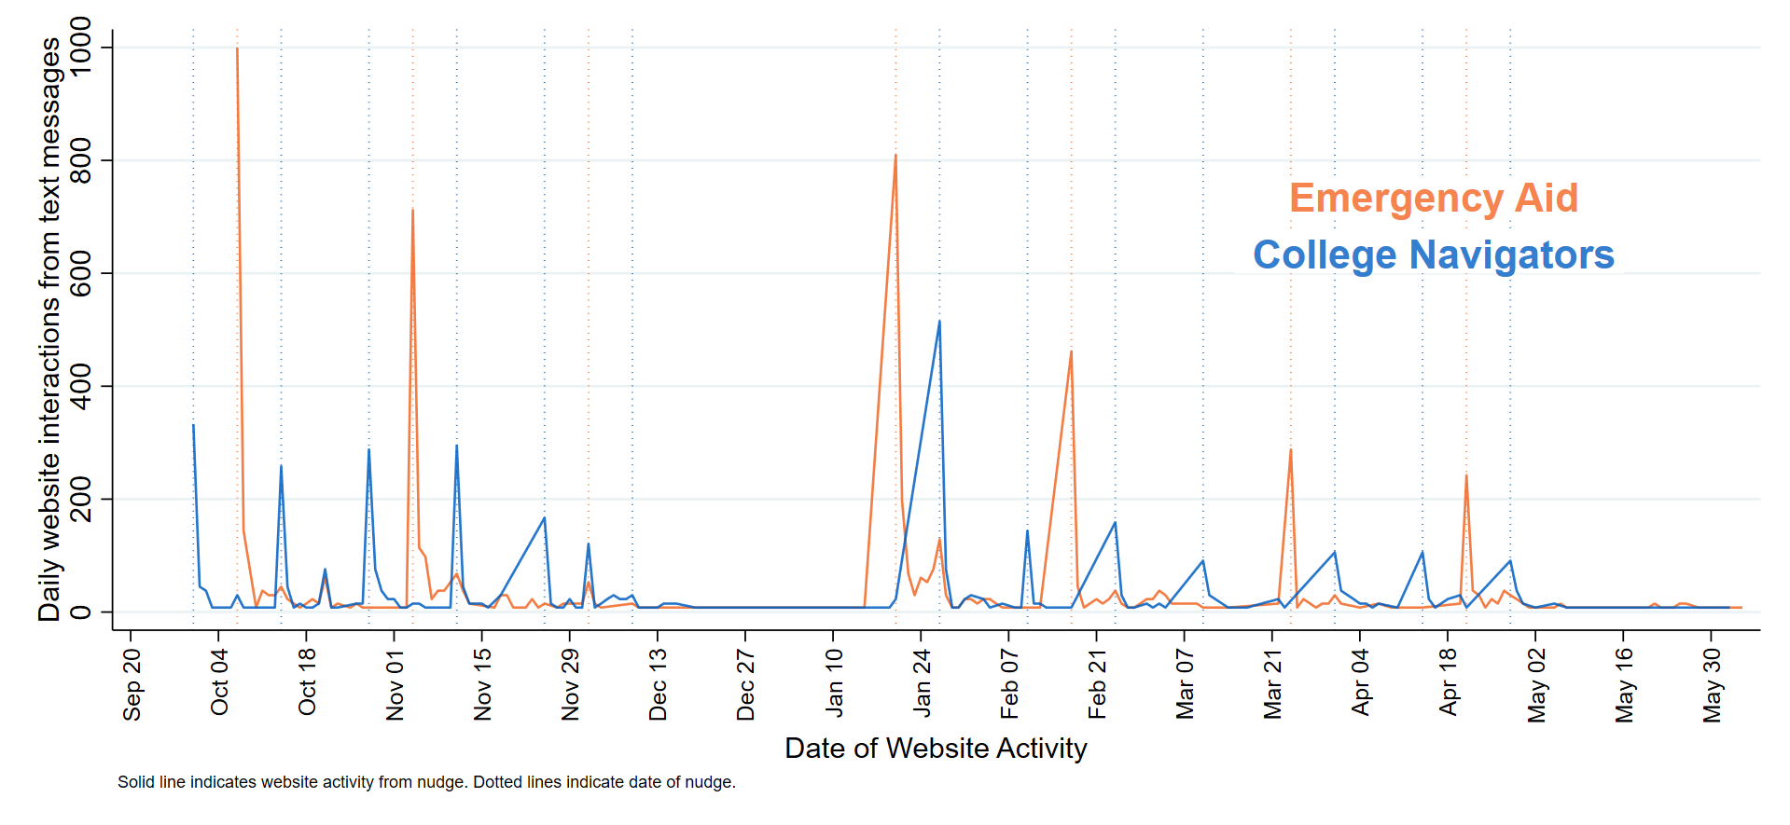

AVERAGE IMPACTS OF NUDGING ON RESOURCE UTILIZATION
Using administrative records from Dallas College, we next examine whether text-based nudging generates improvements in students’ emergency aid applications or outreach to resource navigators. Table 5 shows the average impacts, revealing that nudged students are much more likely to access both resources. Nudging increases the rates at which students apply for emergency aid from approximately 31% to 36% (p<0.001), a 15% improvement. Nudging also increases the rates at which students contact resource navigators from 3.04% to 3.65% (p<0.05), a 20% improvement. Those results do not differ by the type of messaging in the nudge.

TABLE 5 | COMPARISON OF ADJUSTED IMPACTS OF NUDGES ON EMERGENCY AID AND COLLEGE NAVIGATOR ENGAGEMENT RATES, BY STUDY GROUP
 | Emergency Aid |  |  | College Navigator
 | Ref(avg) | Impact (%) | Standard Error (se) | Ref (avg) | Impact (%) | Standard Error (se)
(1) Treatment Groups vs Control (ref) | 31.43 | 4.86 | 0.01 | 3.04 | 0.61 | 0.00
(2) Attuned vs Information Only Nudges (ref) | 34.52 | 0.81 | 0.01 | 3.41 | 0.00 | 0.00
(3) Attuned Nudges vs Control (ref) | 31.77 | 5.26 | 0.01 | 3.09 | 0.61 | 0.00
(4) Information Only Nudges vs Control (ref) | 31.77 | 4.46 | 0.01 | 3.09 | 0.61 | 0.00
N = 18,287
Source | Data on Dallas College Navigator (DCN) engagement are from DCN case management system where Navigators input student engagements via phone, email, or web referrals. Data on Edquity engagement are based on applications for emergency aid submitted to Edquity via cell phone applications and web browser.
Notes | 'Impact' represents log odds based on a logistic regression which controlled for race/ethnicity and FAFSA application status (not equivalent at baseline). Please see Appendix Tables 8, 10, and 11 for adjusted and unadjusted coefficients and standard errors.

In summary, we find that while the type of nudging does not have a meaningful difference in resource utilization, nudging itself has a positive impact on students’ utilization of resources. We hypothesize, based on our non-experimental analysis, that this is likely due to the texts’ influence on empowerment and motivation to seek help.

HETEROGENOUS IMPACTS OF NUDGING ON RESOURCE UTILIZATION
While we find no differences in the nudging type, different modalities may have differential impacts for specific groups of students. Some students may benefit more than others from nudging, depending on their needs, access to information, pre-existing level of resource utilization, and so on. For example, many scholars find Black and Hispanic/Latino men experience disproportionate amounts of shame and stigma when seeking help, men in general, have different help-seeking behaviors than women, and/or help-seeking empowerment may vary based on a student’s current and previous experiences securing financial resources for their education. We conduct two types of heterogeneity analyses. The first examines differences by students’ gender, race/ethnicity, and age. The second examines differences by students’ financial need.

There are many evident differences among the types of students that apply for emergency aid and/or contact resource navigators. Students exhibit clear variation in the patterns of use for both emergency aid and resource navigators depending on their gender, race, and EFC status. Negative EFC provides a good example as to how these pre-existing patterns of difference are likely due, at least in part, to underlying differences in need for support and comfort seeking support. In response to nudging, we see a nine-percentage point boost in applications to emergency aid for students with an EFC of zero or above versus a three-percentage point boost for students with negative EFCs (shown in Appendix Table 12). Nudging was less impactful in getting students ages 18-20, who already had lower rates of emergency aid application, to apply for support (see Appendix Table 16). Instead, students ages 21-25 were particularly receptive to nudging and their application rates rose.

With what we know about the connectedness of various characteristics of students, we also test for interactions. Overall, interactions between race, gender, and nudges show limited meaningful relationships to emergency aid application using the Edquity app. For example, as shown in Table 6, male-identified students are much less likely to apply for emergency aid than female-identified students (-0.47, p<0.001); additionally, nudges have no meaningful impact on male-identified students’ use of the Edquity app while there is a substantial impact for female-identified students (0.22, p<0.001). Black and White students, compared to Latinx students, are more likely to apply for emergency aid yet have no meaningful response to nudges while Latinx students do.

Effect heterogeneity is most pronounced regarding students’ EFC. Use of the Edquity app is more likely for students with a negative EFC (0.95, p<0.001) than those with an EFC above zero and, use of resource navigators follows the same pattern though the relationship is not as strong (Table 6). However, as shown in Table 6, for students with a negative EFC who are nudged, their utilization of the app is 16% less than those who do not have a negative EFC. Similar differences are observed by EFC when it comes to seeking support from resource navigators.

TABLE 6: HETEROGENEITY OF ADJUSTED IMPACTS ON EMERGENCY AID AND COLLEGE NAVIGATOR ENGAGEMENT RATES, BY STUDY GROUP
 | Emergency Aid |  | College Navigators
Category | Impact (b) | Standard Error (se) | Impact (b) | Standard Error (se)
Model 1: Student Gender
Male | -0.47 | 0.05 | -0.28 | 0.14
Nudge x Female (ref) | 0.22 | 0.04 | 0.22 | 0.10
Nudge x Male | 0.04 | 0.07 | -0.10 | 0.19
Model 2: Student Race/Ethnicity
African American / Black | 0.84 | 0.05 | 0.03 | 0.13
White/Caucasian | 0.31 | 0.07 | -1.12 | 0.27
Other | 0.33 | 0.07 | -0.47 | 0.21
Nudge x Hispanic/Latinx (ref) | 0.26 | 0.05 | -0.06 | 0.12
Nudge x African American / Black | -0.05 | 0.08 | 0.38 | 0.18
Nudge x White/Caucasian | -0.16 | 0.10 | 0.82 | 0.34
Nudge x Other | 0.04 | 0.10 | 0.49 | 0.28
Model 3: Negative EFC
EFC < $0 | 0.96 | 0.05 | 0.53 | 0.16
Nudge x EFC >= $0 (ref) | 0.48 | 0.06 | 0.27 | 0.18
Nudge x EFC < $0 | -0.36 | 0.07 | -0.03 | 0.21
N = 18,287
Source | Data above were collected by Dallas College staff obtained from Dallas College and from Edquity applications.
Notes | Impacts are log odds modeled using logistic regression, and controlled for student race and ethnicity, and whether the student completed the FAFSA.Other race/ethnicity includes American Indian, Southeast Asian/Pacific Islander, Multi-Racial, International, and Unknown categories. All other missing outcomes were imputed as zero. Where applicable, missing demographic and outcome data were imputed as zero. See Appendix Table 13 and 15 for unadjusted impacts.

Alternatively, students with negative EFCs may have found the nudging less helpful, as they may have already been especially aware of emergency aid. Or because their circumstances likely include deeper poverty, they may have been less likely to have time to read the texts or even receive them on electronic devices.

On the other hand, students 18-20 years old were much more likely than any other group to reach out to resource navigators (see Appendix Table 15 for details). Race, gender, and their intersection show few meaningful relationships to resource navigator use.

Non-tuition supports may be especially important for students with greater financial need. However, institutions of higher education use a framework for assessing need that brings several limitations. The standard assessment relies on students’ EFC, computed using the Free Application for Student Financial Assistance (FAFSA). Firstly, this requires the filing of a FAFSA which is notably difficult because of the administrative hurdles. Next, the value of the EFC is typically truncated at zero, even though for the most financially marginalized students it may be less than zero. In a recent project, The Hope Center explored the use of negative EFCs with several colleges in Texas and determined that approximately 40% of students have an EFC below zero with a range of $-4,005 to $1,176. Here, we deploy this calculation to allow for a comparison between intervention effects for students with a “true” EFC of $0 to those for students with a negative EFC.

There are several potential explanations for differences in level of engagement with non-tuition supports we see from students with negative EFC compared to students with positive EFC. First, emergency aid may be more important to students who receive relatively less grant support in their financial aid packages and those who are less likely to qualify for public benefits programs, leaving them more reliant on other financial supports such as work. For example, students with a $5,000 EFC will receive a much smaller Pell grant and are less likely to qualify for SNAP than a student with a negative EFC (which as traditionally computed would tend to show up as a $0 EFC and receive a full Pell). As work disappeared during the pandemic, individuals with relatively higher EFCs might be especially helped by a reminder to seek emergency aid.

IMPACTS OF NUDGING ON ACADEMIC OUTCOMES
Above we describe the impact of nudges on utilization of emergency aid and Dallas College Navigators; in this section we examine the impact of nudges on academic outcomes. Specifically, we provide an assessment of the impact of nudges and subsequent application of emergency aid through the use of the Edquity app on academic outcomes. We explore how nudging to supports impacts credit attainment (using a credits attempted-to-completed ratio), GPA, retention and completion across three terms. Importantly, the first two terms examined are measured concurrently with the receipt of the nudges allowing us to estimate an immediate impact if one is present.

While the impact trends in the right direction (as shown in Figure 3 below), the majority of our findings show relatively small differences. We see slightly more nudged students, and slightly more students nudged with “attuned” messaging, in the highest GPA category (3.0-4.0) as compared to their peers in the first term though this pattern reverses in the second and third terms of evaluation. We find a positive impact on percent cumulative degree completion (p<0.01) in Terms 2 and 3 over Term 1. In the third term, “attuned” messaging also has a positive impact on students’ credit accumulation ratio (p<0.01).

FIGURE 3 | ADJUSTED IMPACTS OF NUDGING ON ACADEMIC OUTCOMES (ITT)

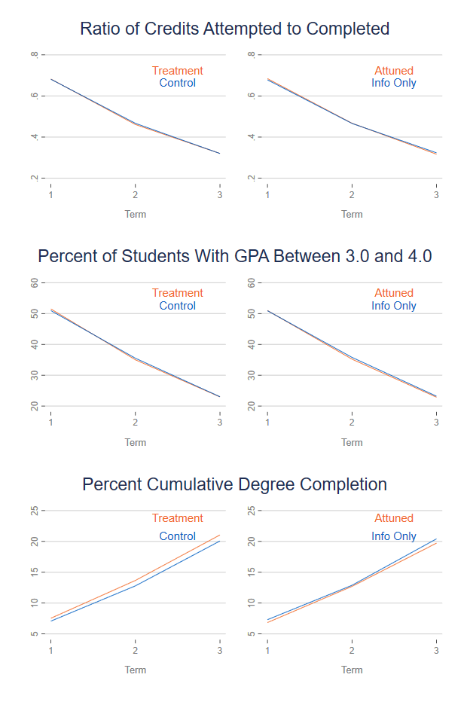
As show on in Figure 3, in this intervention, nudging also has a positive impact on degree completion each term following treatment (ES=0.47, 0.88, 0.98; (p<0.05). We also see impacts of “attuned” messaging on these outcomes as compared to information-only nudging (see Appendix Tables 18 and 19).

It is possible, however, that the nudging may have a different impact for those who utilized the resources; we call this a “treatment-on-the-treated” estimate and display the results in the figure above with a subsample of students (see Figure 4) – those that responded to the invitation to use the Emergency Aid resource by submitting an application in the Edquity app.

FIGURE 4 | ADJUSTED IMPACTS OF NUDGING ON ACADEMIC OUTCOMES (TOT)

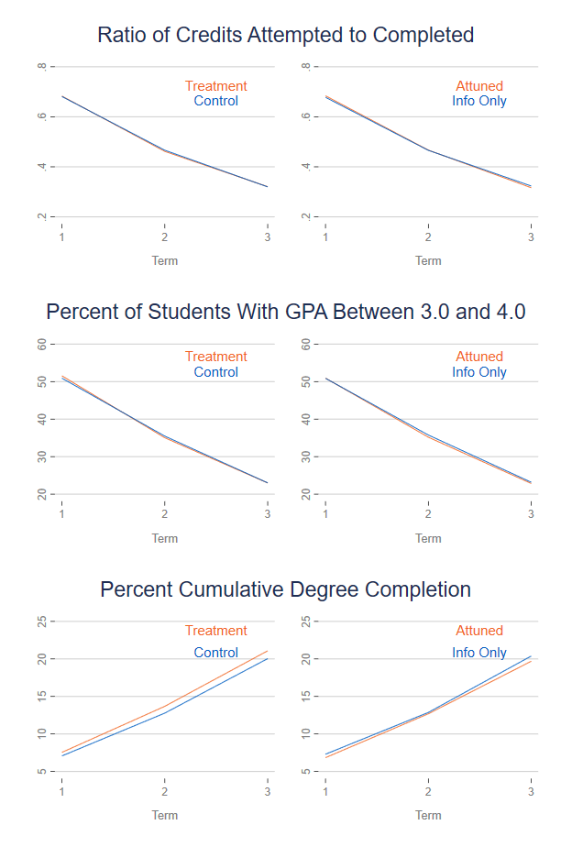
The patterns found across all nudged students hold when taking into account emergency aid engagement during the first term following treatment though the differences are smaller than when simply comparing students that were nudged or not. Students that were nudged, and applied for emergency aid, were more likely to complete their degree by the third term than their peers (p<0.05). While the patterns trend in the same direction, the impacts on credit accumulation and GPA are very small and are not statistically significant (see Appendix Tables 20).

HETEROGENOUS IMPACTS OF NUDGING ON ACADEMIC OUTCOMES
As with the outcomes above, we anticipate that the nudges may have differential impacts for certain students. Therefore, we next examine the impact of being nudged and applying for emergency aid on completion rates by race, gender and EFC status given the differences in likelihood of engagement based on these characteristics. In Figure 5, the main effects for students who identify as male are less likely than their female peers to have positive impacts from the nudges on completion (p<0.05) as are African-American identifying students (p<0.001). Likewise, as with utilization, there are differences based on EFC status. Students with an EFC below $0 are less likely to complete college as a result of the nudges than their higher EFC peers (p<0.10).

FIGURE 5 | ADJUSTED IMPACTS OF NUDGING ON ACADEMIC OUTCOMES
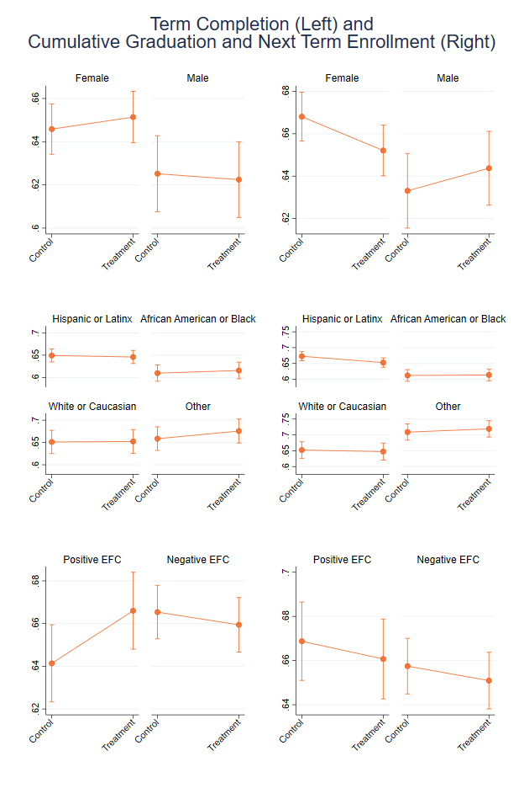
However, there are few other statistically significant relationships between student characteristics and the impact of nudging on completion and the interactions between being nudged and these characteristics are not statistically significant. In other words, nudging does not appear to have a differential impact on the student subgroups’ likelihood of completion examined here (see Appendix Tables 21, 22, and 23).

CONCLUSION

During the pandemic, community colleges and their students are seeking new ways to improve knowledge and utilization of crucial resources that can address college affordability and secure their basic needs. Recent federal investments in higher education provide the resources to meet the present need. Yet, distributing support equitably and efficiently remains a struggle. The American Rescue Plan Act requires colleges and universities to implement practices supporting the distribution of emergency aid and conduct outreach to students regarding the potential to receive adjustments to their federal financial aid. However, it provides little guidance on how institutions should achieve these goals. This paper identifies a promising first step with the potential to both improve equitable and efficient knowledge and utilization of these resources: text-based nudging.

Implemented across a large Texas community college district, weekly nudges reminding students of available campus supports substantially boosted their applications for emergency aid and increased the odds that they would reach out to resource navigators. This very likely increased their financial resources and connection to public benefits. In some cases, this was more likely when “attuned” messaging was used.

While the impact estimates in this study are smaller than those observed in a prior study at another Texas community college, both Amarillo College and its study sample were much smaller, and the sender of the nudges was known to many on campus. The results in this study may be more generalizable to a broader number of colleges, universities, and students, particularly to community college districts and larger colleges and universities. We find that nudging brings additional benefits for students, leading them to feel more empowered when the messages included “attuned” language. That type of language was especially important when urging students to apply for public assistance.

Male-identified students, as well as those who are less likely to be eligible for public benefits, were particularly likely to respond to nudges by seeking emergency aid though we see no notable differences in the overall impact by message type. While nudges changed engagement with resources, we see little direct impact on outcomes because of nudging for these groups in particular as compared to the general study sample.

In sum, community colleges can meaningfully improve students’ access to existing non-tuition resources through nudging. They may be able to further their efforts by using pandemic relief funding and other federal basic needs funding and it appears engagement with these resources may positively impact likelihood of college completion though the impacts are small. Text messages are inexpensive to send and students who can benefit from this support are easily identified using administrative data. Stigma-reducing or “attuned” messaging may be especially useful for certain types of resources and students, though providing only information is also impactful. These efforts represent a potentially low-cost, high-impact use of federal funds that will help institutions meet institutional obligations required through the recent American Rescue Plan Act. Advancing this approach during the pandemic has the potential to reduce financial insecurities and improve student well-being. Further replication and testing are warranted and important for community college student success.

NOTES
Financial disclosure: In addition to serving as Founding Director of The Hope Center, Dr. Goldrick-Rab
also created the FAST Fund, a faculty-run emergency aid program operated by the nonprofit Believe in
Students, and she is Chief Strategy Officer at Edquity, a private company also distributing emergency
aid. Edquity’s approach to emergency aid uses an algorithm that Dr. Goldrick-Rab developed based on
her research. She is a paid consultant and holds stock in the company

ACKNOWLEDGEMENTS
This research is supported by the Institute of Education Sciences, U.S. Department of Education, through Grant # R305N170020 - 20A to Temple University. The opinions expressed are those of the authors and do not represent the views of the Institute or the U.S. Department of Education. We thank Dallas College, Edquity, and SignalVine, as well as program officer James Benson, for project support. The Hope Center for College, Community, and Justice uses a collaborative model of research and thus we are deeply grateful to a number of Hope Center staff, in particular, Vanessa Coca and Sarah Magnelia.

SUGGESTED CITATION

Baker-Smith, Gill, J., Goldrick-Rab, S., C., Bettinger, E., Walton, G., Brady, S., & Looker, E. (2022, February). Connecting community college students to non-tuition supports during the COVID-19 pandemic. The Hope Center for College, Community, and Justice.

ENDNOTES

National Student Clearinghouse (2021, November). Undergraduate enrollment declines nearly 8% and community colleges drop 15% since fall 2019.
Brown, S. (2020, March). When covid-19 closed colleges, many students lost jobs they needed. Now campuses scramble to support them. The Chronicle of Higher Education.
Baker-Smith, C., Coca, V., Goldrick-Rab, S., Looker, E., Richardson, B., & Williams, T. (2020). #RealCollege 2020: Five years of evidence on campus basic needs insecurity. The Hope Center for College, Community, and Justice.
The Hope Center for College, Community, and Justice. (2021). #RealCollege2021: Basic needs insecurity during the ongoing pandemic.
The Hope Center for College, Community, and Justice. (2021). #RealCollege2021: Basic needs insecurity during the ongoing pandemic.
Garcia, C.M., Ptak, S.J., Stelzer, E.B., Harwood, E.M., & Brady, S.S. (2014). ’I connect with the ringleader’: Health professionals’ perspectives on promoting the sexual health of adolescent males. Research in Nursing & Health; Small, M.L. (2009). Unanticipated gains: Origins of network inequality in everyday life. Oxford University Press, New York.
Pattyn, E., Verhaeghe, M., Sercu, C., & Bracke, P. (2014). Public stigma and self-stigma: Differential association with attitudes toward formal and informal help seeking; Psychiatric Services. Snowden, L.R. (1998). Racial differences in informal help seeking for mental health problems. Journal of Community Psychology.
Ainsworth, R., Dehejia, R., Pop-Eleches, C., & Urquiola, M. (2020). Information, preferences, and household demand for school value added. National Bureau of Economic Research Working Paper 28267; Bettinger, E. P., Long, B. T., Oreopoulos, P., & Sanbonmatsu, L. (2012). The role of application assistance and information in college decisions: Results from the H&R Block FAFSA experiment. The Quarterly Journal of Economics; Cohodes, S., Corcoran, S., Jennings, J., & Sattin-Bajaj, C. (2022). When do informational interventions work? Experimental evidence from New York City High School Choice. NBER Working Paper 29690.
Crutchfield, R., Carpena, A., McColyn, T., & Maguire, J. (2020). The starving student narrative: how normalizing deprivation reinforces basic need insecurity in higher education. Families in Society; Goldrick-Rab, S., Hernandez, D., Coca, V., Williams, T., & Richardson, B. (2020). Houston food scholarship program report. The Hope Center for College, Community, and Justice; Henry, L. (2020). Experiences of hunger and food insecurity in college. Palgrave Macmillan; Stebleton, M.J., Lee, C.K., & Diamond, K.K. (2020). Understanding the food insecurity experiences of college students: A qualitative inquiry. The Review of Higher Education.
Hoxby, C., & Turner, S. (2013). Expanding college opportunities for high-achieving, low income students. Stanford Institute for Economic Policy Research Discussion Paper; Wiswall, M., & Zafar, B. (2015). Determinants of college major choice: Identification using an information experiment. The Review of Economic Studies; Bettinger, E. P., Long, B. T., Oreopoulos, P., & Sanbonmatsu, L. (2012). The role of application assistance and information in college decisions: Results from the H&R Block FAFSA experiment. The Quarterly Journal of Economics; Bhargava, S., & Manoli, D. (2015). Psychological frictions and the incomplete take-up of social benefits: Evidence from an IRS field experiment. American Economic Review; Page, L. C., Castleman, B. L., & Meyer, K. (2020). Customized nudging to improve FAFSA completion and income verification. Educational Evaluation and Policy Analysis.
American Association of Community Colleges. (2016, November). Data points: On-campus housing.
Ha, L., Joa, C. Y., Gabay, I., & Kim, K. (2018). Does college students’ social media use affect school e-mail avoidance and campus involvement? Internet Research.
Goldrick-Rab, S., Clark, K., Baker-Smith, C., & Witherspoon, C. (2021). Supporting the whole community college student: The impact of nudging for basic needs security. The Hope Center for College, Community, and Justice.
Yeager, D. S., Purdie-Vaughns, V., Garcia, J., Apfel, N., Brzustoski, P., Master, A., Hessert, W. T., Williams, M. E., & Cohen, G. L. (2014). Breaking the cycle of mistrust: Wise interventions to provide critical feedback across the racial divide. Journal of Experimental Psychology: General; Walton, G. M., & Brady, S. T. (2020). “Bad” things reconsidered. Applications of Social Psychology.; Hall, C. C., Zhao, J., & Shafir, E. (2014). Self-affirmation among the poor: Cognitive and behavioral implications. Psychological Science.
Thomas, C. C., Otis, N. G., Abraham, J. R., Markus, H. R., & Walton, G. M. (2020). Toward a science of delivering aid with dignity: Experimental evidence and local forecasts from Kenya. Proceedings of the National Academy of Science.
Ramirez, G., Covarrubias, R., Jackson, M., & Son, J. Y. (2021). Making hidden resources visible in a minority serving college context. Cultural Diversity and Ethnic Minority Psychology.
Bird, K. A., Castleman, B. L., Denning, J. T., Goodman, J., Lamberton, C., & Rosinger, K. O. (2021). Nudging at scale: Experimental evidence from FAFSA completion campaigns. Journal of Economic Behavior & Organization.; Page, L. C., Lee, J., & Gehlbach, H. (2020). Conditions under which college students can be responsive to nudging. EdWorkingPaper No. 20-242. Annenberg Institute, Brown University; Castleman, B.L. & Page, L.C. (2016). Freshman year financial aid nudges: An experiment to increase FAFSA renewal and college persistence. Journal of Human Resources.; Page, L. C., Castleman, B. L., & Meyer, K. (2020). Customized nudging to improve FAFSA completion and income verification. Educational Evaluation and Policy Analysis.
Page, L. C., Sacerdote, B., Goldrick-Rab, S., & Castleman, B. (2019). Financial aid nudges: A national experiment with informational interventions. The Hope Center for College, Community, and Justice.
Cannon, R. & Goldrick-Rab, S. (2015). Why didn’t you say so? Experimental impacts of a financial aid call center. Wisconsin HOPE Lab.
Goldrick-Rab, S., Clark, K., Baker-Smith, C., & Witherspoon, C. (2021). Supporting the whole community college student: The impact of nudging for basic needs security. The Hope Center for College, Community, and Justice.
Collier, D., Fitzpatrick, D., & Nichols, A. (2021, June). Experimental evidence on which academic outcomes nudging can shift for first-year college students from high-FRL schools.
Hall, C. C., Zhao, J., & Shafir, E. (2014). Self-affirmation among the poor: Cognitive and behavioral implications. Psychological Science.
See Appendix H-3 for details on the comparison between this sample and Dallas College.
Manfield, L. (2020, March). Dallas handed out subsidies in exchange for affordable housing. Developers got around it. Dallas Observer.
Wisconsin HOPE Lab. (2017). Dallas community college district: District report from fall 2016 survey of student basic needs. University of Wisconsin-Madison.
In Appendix Table H-6 we provide response rates for the survey outcomes (see Appendix H-5 for differences between full and survey sample). These outcomes are not analyzed for causal impact and do not contribute to sample attrition; they only provide implementation information.
The survey also included questions on experiences with existing supports and basic needs insecurity. However, these serve as contextual information at baseline and are not analyzed in this paper.
Due to low initial response rates one month into fielding (December 2020-January 2021) we subsequently added a lottery for an additional $100 to a random sample of any remaining respondents and adjusted recruitment text accordingly. Final response rate was 33% for treatment students and 43% control students.
Kraft, M. (2020). Interpreting effect sizes of education interventions. Educational Researcher.
Data for Dallas College Navigator is much less complete as it was collected by hand and thus may reflect either a lower usage rate than the Edquity app or may simply be a result of missing data in program administration.
Kalmuss, D., & K. Austrian. Real men do. . . Real men don’t: Young Latino and African American men’s discourses regarding sexual health care utilization. American Journal of Men’s Health.; Walton, G.M., & Cohen, G.L. (2011). “A brief social-belonging intervention improves academic and health outcomes of minority students. Science.; Walton, G.M. & G.L. Cohen. (2007). “A question of belonging: race, social fit, and achievement. Journal of Personality and Psychology.
Courtenay, W.H. (2000). Constructions of masculinity and their influence on men’s well-being: A theory of gender and health. Social Science & Medicine.; Levant, R.F. & Wimer, D.J. (2014). Masculinity constructs as protective buffers and risk factors for men’s health. American Journal of Men’s Health.; Smith, J.A., Braunack-Mayer, A., & Wittert, G. (2006). What do we know about men’s help-seeking and health service use? Medical Journal of Australia; Walton, G.M., Logel, C., Peach, J.M., Spencer, S.J., & M.P. Zanna. (2015). Two brief interventions to mitigate a “chilly climate” transform women’s experience, relationships and achievement in engineering. Journal of Educational Psychology.
Castleman, B.L. & L.C. Page. (2013). “A trickle or a torrent? Understanding the extent of summer “melt” among college-intending high school graduates.” Social Science Quarterly, v95(1), 202-220; Goldrick-Rab, S. (2016). Paying the price: College costs, financial aid, and the betrayal of the American dream. University of Chicago Press; Langhout, R.D., Drake, P., & F. Roselli. (2009). Classism in the university setting: Examining student antecedents and outcomes. Journal of Diversity in Higher Education.
Dynarski, S. & Wiederspan, M. (2012). “Student aid simplification: Looking back and looking ahead.” National Tax Journal.; Goldrick-Rab, S. (2016). Paying the price. College costs, financial aid, and the betrayal of the American dream. University of Chicago Press.
Conroy, E.V., Magnelia, S., Dahl, S., & Goldrick-Rab, S. (2021). The real price of college: Estimating and supporting students’ financial needs. The Hope Center for College, Community, and Justice.
The Hope Center for College, Community, and Justice. (2021). Real price of college toolkit. The Hope Center for College, Community, and Justice. Philadelphia, PA.
The only data for which we can connect utilization to student identifiers is the Edquity app and thus this analysis is limited to use of the Edquity app alone.
U.S. Department of Education, Higher Education Emergency Relief Fund III (2021, May) Frequently asked questions.
Goldrick-Rab, S., Clark, K., Baker-Smith, C., & Witherspoon, C. (2021). Supporting the whole community college student: The impact of nudging for basic needs security. The Hope Center for College, Community, and Justice.

